

**MAHARASHTRA STATE BOARD OF TECHNICAL EDUCATION, MUMBAI**

A Semester V Project Report on

Grocery Management System

Submitted in partial fulfillment for the award of

Diploma in Computer Engineering

Manish Yuvraj Patil

Abhishek Raju Falke

Harshit Arun Gujarathi

Om Ajay Shirudkar

Guided by

Dushyant Potdar Sir



**DEPARTMENT OF COMPUTER ENGINEERING**

**S.S.V.P.S's Bapusaheb Shivajirao Deore Polytechnic, Dhule**

**(Institute Code : 1100)**

**2020 - 2021**



**MAHARASHTRA STATE BOARD OF TECHNICAL EDUCATION, MUMBAI**

**S.S.V.P.S's Bapusaheb Shivajirao Deore Polytechnic, Dhule**

**DEPARTMENT OF COMPUTER ENGINEERING**

**CERTIFICATE**

This is to certify that

1811000017 - PATIL MANISH YURAJ. ,

1811000018 - FALKE ABHISHEK RAJU ,

1811000022 - GUJARATHI HARSHIT ARUN.,

1811000030 - SHIRUDKAR OM AJAY.

From **S.S.V.P.S’s B.S.Deore Polytechnic, Dhule** has completed ***Semester V Project Report*** having title Grocery Management System in a group consisting of 4 persons under the guidance of the Faculty Guide.

Place : Dhule Guide

Date : Dushyant Potdar

**Acknowledgement**

We would like to express our sincere gratitude towards our Mentor Podar sir provided us with such a knowledgeable project to work upon. I would like to extend our sincere thanks to them. We are highly indebted to the Reliance Mart, Reliance Fresh, and Reliance Footprint for their guidance and constant supervision as well as for providing necessary information regarding the project and also for their support in completing the project. We would like to express our gratitude towards our parents and teachers of our college for their kind cooperation and encouragement which helped us in completing this project successfully. . Lastly, special thanks and appreciation also goes to the group members without whose new ideas and efforts this project could not be completed.

There is lot of work and stress to be an owner of grocery store as owner need to maintain their reputation worries about their product selling and stock maintains that we understand during project

Understanding the effect of owner which need to be digital day by day billing system are introduced which is not a cup of tea for Senior Citizen to handle laptop or work maximum time on computer

Understood how Actually the grocery store is maintain how actually the product price is decided which brand is mainly liked by customers how to do stock management how to deal with Wholesaler how to face and find solution difficulties when the customer selected

During the condition of pandemic what impact happen as a owner of grocery store we observed about that what impact happen during this condition as Owner

we should thanks the owner of the shop **Sadguru provision** to give valuable information about How the Stock management process is done understood the procedure how to facing problems while the owner of Grocery store

**Abstract**

This project is a about grocery store Management . Starting with the introduction to grocery store the project proceeds towards the owner profile of grocery store

A Grocery Store is retail store that primarily sells food. A grocery is a bulk seller of food . Wheat, rice, pulses, oil, cosmetics, etc. are the part of the life such that they can not be seen as different from life. These products are available quickly and frequently at any store, every store has their set of grocery products which need to be managed properly

This System help to maintain record in Stock Management it help to calculate the basic price of product by selecting the particular name of product in the form of list in which owner need to enter the price and total of Selected item is automatically calculated the total price of selected item

The owner can do rough calculation of item that client want to by selecting item in list that depend on quanity , quality and the Product Brand in the Rough Calculation This project can help in Large scale and well as Small Scale Grocery store

This project try to reduce the owner stress by providing basic features in digital format such as

* Billing System - Making the list of Selected Items for customers with Auto calculation with the help of form
* Rough Calculation: Doing the rough work by making a list of customer Requirement with the help of item list , item Quantity.
* Stock Management : Storing the records and Ordering the product as per Requirement with the help of Stock Management Table

**Content Page Title**

|  |  |  |
| --- | --- | --- |
| **Chapter** | **Title** | **Page no** |
|  | Acknowledgement | 3 |
|  | Abstract | 4 |
| 1 | Introduction and background of the industry or User based Problem   * 1. Introduction   2. Existing System   3. Limitation | 6  6  7 |
| 2 | Literature Survey for Problem Identification and Specification  2.1 Literature Survery  2.2 Problem Definitions | 8  8 |
| 3 | Proposed Detailed Methodology of solving the identified problem with action plan  3.1 Proposed Methodology  a. Planning  b. Design  3.2 Requirements  3.3. Refreneces | 9  10  11  11 |

**Chapter 1 : Introduction and background of the industry or User based Problem**

* 1. **Introduction**

Grocery Store is retail store that primarily sells food.A grocery is a bulk seller of food.Wheat, rice, pulses, oil, cosmetics, etc. are the part of the life such that they can not be seen as different from life. These products are available quickly and frequently at any store, every store has their set of grocery products which need to be managed properly

The grocery management system has developed to override the problems prevailing In it he practing manual system this web based application I supported to elimate and in some case reduced the hardship faced by exciting web based application moreover this system is design for particular owner to face their daily problems while in a store

In this system the owner of grocery store can perform multiple task such as digital billing , rough calculation of item for customer using rough calculator and the main Stock Management for grocery store .

* 1. **Existing System**

A **grocery store** is a **retail store** that primarily sells **food**. This is a internet based application that is accessed through web

This **system** can be used to search for the item properties such as Item Brand , Retail Price of a particular product ,

Information about Stock Management . such as Ordering item as per Brand

which brand product need to be order as per demand and Quantity as per Requirement which brand need to be order as per set

Information about Billing System creating a bill is a major task to type the name of selected product and doing calculation in this system the user need to selected the product by a list and with auto calculation it is a cup of tea for anyone to make a bill

Information about Rough Calculation this features help the owner to edit or add the customer list as with price and input the quantity of a product and that give result a rough total price as selected products

* 1. **Limitation**

This system has following limitation

1. Out of Stock Product message is displayed but the owner need to contact wholesaler for ordering the stock
2. Product the selected product that are present in list those product has been selected by owner which brand he/she want to display in list With selected price
3. Customer Satisfaction customer need a specific brand of products as per their conditions we try to add all brand product but mainly human behaviour we cannot fully satificate customer with their favorite brand is added in a list or not

**CHAPTER 2 : Literature Survey for Problem Identification and Specification**

**2.1 Literature Survery**

As pervious Grocery store Management project has following features For only large grocery store

* Shopping List
* Delievery form
* Stock Management
* Billing System

But in this project new Features are added for both Small Scale and

Large Scale Grocery store

* Billing System – Selected item + Auto Calculated
* Rough Calculator –Selected item + Auto Calculated Feature
* Stock Management

**2.2 Problem Definitions**

In this web based Application the user ie Owner has to login with given login details to perform task such as Billing system , Rough Calculation and Stock Management

* Billing System - Making the list of Selected Items for customers with Auto calculation with the help of form
* Rough Calculation : Doing the rough work by making a list of customer Requirement with the help of item list , item Quantity.
* Stock Mangement : Storing the records and Ordering the product as per Requirement with the help of Stock Mangement Table

**Chapter 3 : Proposed Detailed Methodology of solving the identified problem with action plan**

**3.1 Proposed Methodology**

* Planning

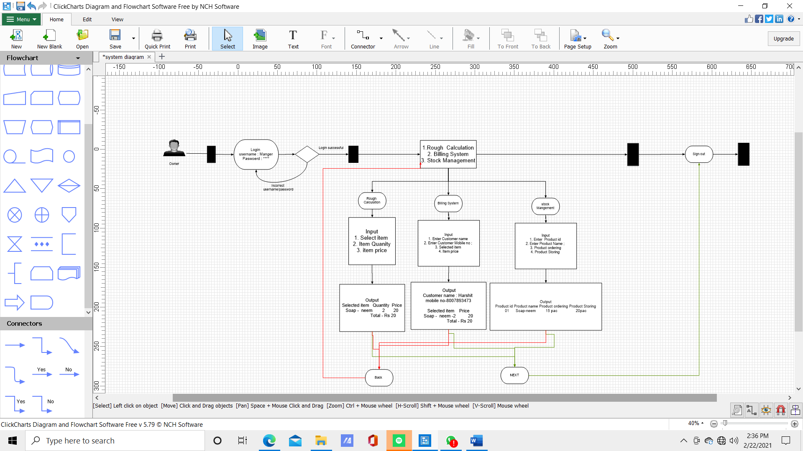

**Figure : System Diagram**

Owner has to login given username and Password if the user does not enter the correct username and password then he or she does not do perform tasks

A three button has been displayed in the screen as Rough calculation, billing System and Stock Management the user need to select one at time One of the task at time

Following are the condition of the system

Condition 1

if the user select rough calcaluation option the Select item form list then Enter the quantity as per customer requirement then the owner need to enter the price of the products

Condition 2

if the user select Billing System option then the user need to enter the customer name and mobile number for sercuity reason later he need to added the selected item form the list and later enter the price of Selected product later click on submit button

Condition 3

If the user selected Stock Management option then the user need to enter the product id and product name to order the product or store the product

The user cannot choose multiple option at a time the user need to click on two buttons as follow

1. Back

when the user Click button back button task menu has been displayed

1. Next

when the user Click on Next button then the user moved to the sign out optio

* Design

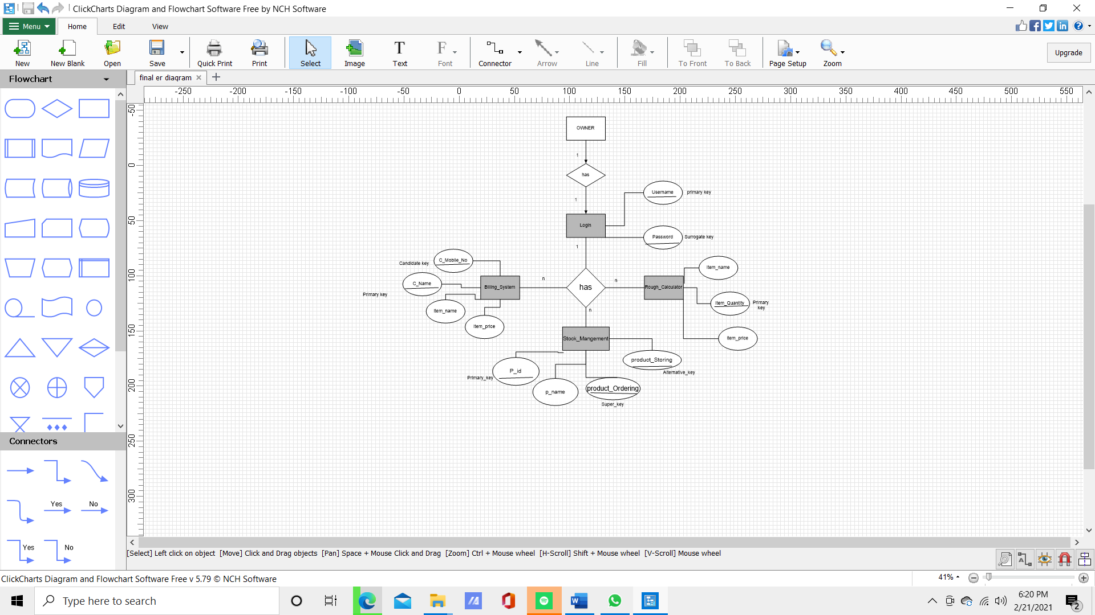

**Figure : ER Diagram for Grocery Management System**

ER Diagram display about attributes used in this system such as

Owner and login attributes show the one to one Relationship in which Username and password columns are assigned as primary key and Surrogate key

login and rough calculation attributes show the one to many Relationship in which item Quantity is assigned as primary key and the remaining attribute are item name and item price

login and billing system attributes show the one to many Relationship in which Customer mobile no , customer name are assigned as primary key and Candidate key and the remaining attribute are Item name and item price

login and Stock Management attributes show the one to many Relationship in which Product id, Product ordering, product Storing are assigned as primary key , alternative key and Super key

**3.2 Requirements**

1. Product
2. Desktop ,PC Or any compatable device
3. Operating system
4. Xampp server

**3.3 Reference**

1. Sadguru provision (Grocery shop)
2. <https://www.slideshare.net/pujithaboggarapu/grocery-management-system> (Online reference)
3. <https://www.freeprojectz.com/paid-projects/php-mysql/grocery-shop-management-system> (Online Reference)